
RECOVERY EU Pharmacy Briefing
(Based on Core Protocol V28.0 2025-06-30 and EU Region-Specific Appendix V2.0 2025-06-30)

Contents
1 Introduction 2
2 Dexamethasone 3
2.1 Initial supply and re-ordering 3
2.2 Storage 3
2.3 Dispensing 3
2.4 Returns and Destruction 3
2.5 FAQs 3
3 Prednisolone 4
3.1 Initial supply and re-ordering 4
3.2 Storage 4
3.3 Dispensing 4
3.4 Returns and Destruction 4
4 Hydrocortisone 4
4.1 Initial supply and re-ordering 4
4.2 Storage 4
4.3 Dispensing 5
4.4 Returns and Destruction 5
5 Oseltamivir 5
5.1 Initial supply and re-ordering 5
5.2 Storage 5
5.3 Dispensing 5
5.4 Returns and Destruction 5
5.5 FAQs 5
6 Baloxavir marboxil 6
6.1 Initial supply and re-ordering 6
6.2 Storage 8
6.3 Dispensing 8
6.4 Returns and Destruction 9
6.5 Recalls, complaints or use of expired IMP 9
6.6 FAQs 9
7 Version History 10

Introduction
RECOVERY is an open-label platform trial evaluating treatments for patients hospitalised with influenza or community-acquired pneumonia (CAP) caused by other pathogens. Several previous treatments have been evaluated in RECOVERY, and the IMPs being evaluated in the EU are listed in the table below (treatment comparisons “G”, “H”, “I” and “M” from the core protocol). IMPs for the oseltamivir and corticosteroid comparisons are supplied, labelled and accounted for as if given as part of routine care, without any trial specific procedures. Trial-specific baloxavir marboxil is supplied to sites via the Roche distribution network. Prescriptions of all trial IMPs should be written in the same manner as for usual care, with no additional documentation (unless there is a local requirement for this). Depending on local requirements, trial IMP may need to be prescribed by a doctor specifically delegated to do this, or it may be acceptable for any attending doctor to prescribe the IMP (this can be confirmed with the site PI). Only adults (aged ≥18 years) are eligible in the EU.

Table 1: IMPs in RECOVERY
Medicine |  | Formulation | Source | IMP-specific training &  delegation¹ | Trial-specific accountability log required | Trial specific labelling
 | Randomisation Part G (baloxavir marboxil comparison – patients with influenza)
Baloxavir marboxil |  | Oral tablet | Roche trial specific stock | Yes | No²  (accountability as for routine care) | Yes
 | Randomisation Part H (oseltamivir comparison – patients with influenza)
Oseltamivir |  | Oral capsule, oral suspension | Hospital pharmacy stock used for routine care | No | No  (accountability as for routine care) | No
 | Randomisation Part I (corticosteroid comparison – patients with influenza)
Dexamethasone |  | Oral tablet, oral suspension, intravenous ampoules | Hospital pharmacy stock used for routine care | No | No  (accountability as for routine care) | No
Prednisolone  (alternative for pregnant/ breastfeeding women) |  | Oral tablets, oral suspension | Hospital pharmacy stock used for routine care | No | No  (accountability as for routine care) | No
Hydrocortisone  (alternative for pregnant/ breastfeeding women) |  | Intravenous ampoules | Hospital pharmacy stock used for routine care | No | No  (accountability as for routine care) | No
 | Randomisation Part M (corticosteroid comparison – patients with community-acquired pneumonia)
Dexamethasone |  | Oral tablet, oral suspension, intravenous ampoules | Hospital pharmacy stock used for routine care | No | No  (accountability as for routine care) | No
Prednisolone  (alternative for pregnant/ breastfeeding women) |  | Oral tablets, oral suspension | Hospital pharmacy stock used for routine care | No | No  (accountability as for routine care) | No
Hydrocortisone  (alternative for pregnant/ breastfeeding women) |  | Intravenous ampoules | Hospital pharmacy stock used for routine care | No | No  (accountability as for routine care) | No
¹ Required for at least one member of the pharmacy team.
² A record must be kept of IMP deliveries, use, and inventory, in line with usual pharmacy procedures for handling medications. Example accountability logs for baloxavir marboxil with minimally required information will be provided, but sites may choose to use their own local methods.

In each comparison, patients are randomly allocated in a 1:1 ratio to the trial treatment or usual care without that trial treatment. Participants may be allocated to >1 trial treatment if they enter >1 comparison (e.g. patients with influenza could be allocated to receive baloxavir marboxil, oseltamivir and corticosteroids if they enter all three comparisons). If participants are allocated to ‘usual care’ they do not require a prescription (there is no placebo). All trial treatments should be started as soon as possible after randomisation, aiming for a delay of no more than 6 hours.

Example SmPCs for IMPs are available on the trial website (www.recoverytrial.net/eu/regulatory-documents), which provide trial Reference Safety Information (SmPC section 4.8). For specific information about locally supplied IMPs (e.g. storage, excipients, expiry), refer to the relevant SmPC for that formulation.

Dexamethasone

Initial supply and re-ordering
Dexamethasone will be sourced by the local pharmacy procurement team via their standard procedures. The locally available formulation can be used.

Storage
See SmPC for the formulation used at the site. No temperature excursion reporting required to the trial team. Follow local SOPs to manage temperature excursions.

Dispensing
The regime is identical for Randomisation Part I (corticosteroids for influenza) and Randomisation Part M (corticosteroids for CAP):
Dexamethasone administered by mouth, feeding tube or intravenously.
Duration 10 days, stopped on discharge from hospital if this happens sooner
Dose 6mg
Frequency Once daily

Note, an alternative corticosteroid with less fetal/infant exposure should be used in pregnant or breastfeeding women (this can be either prednisolone orally or hydrocortisone intravenously as described below).

Returns and Destruction
Any unused stock should be disposed of in the usual manner. No approval from sponsor is required.

FAQs
How is dexamethasone to be prescribed as there are different salts available?
To be prescribed as dexamethasone base

Is the dose the same for oral and intravenous for dexamethasone despite differences in bioavailability?
Yes, the dose will be as the base for both intravenous and oral.

How should the oral dose be taken?
Dexamethasone should ideally be taken with or after food to minimise irritation to the gastrointestinal tract.

Our normal hospital practice is to dissolve dexamethasone 2mg tablets instead of using soluble tablets or oral liquid, is this permitted?
Yes. If sites cannot source the soluble tablets or liquid, then the 2mg tablets can be dissolved in 10mL of water. There are no issues with this going down a fine bore nasogastric tube.

Is intravenous dexamethasone to be given as an intravenous bolus or infusion?
Either is acceptable, the treating clinician can decide.

Prednisolone

Initial supply and re-ordering
Prednisolone will be sourced by the local pharmacy procurement team via their standard procedures. The locally available formulation can be used.

Storage
See SmPC for the formulation used at the site. No temperature excursion reporting required to the trial team. Follow local SOPs to manage temperature excursions.

Dispensing
Pregnant and breastfeeding women should receive either prednisolone or hydrocortisone instead of dexamethasone (if it’s necessary to change the route of administration, women can switch between prednisolone and hydrocortisone, but the treatment end date should remain the same). The regime is identical for Randomisation Part I (corticosteroids for influenza) and Randomisation Part M (corticosteroids for CAP):
Prednisolone administered by mouth or feeding tube.
Duration 10 days, stopped on discharge from hospital if this happens sooner
Dose 40mg
Frequency Once daily

Returns and Destruction
Any unused stock should be disposed of in the usual manner. No approval from sponsor is required.

Hydrocortisone

Initial supply and re-ordering
Hydrocortisone will be sourced by the local pharmacy procurement team via their standard procedures. The locally available formulation can be used.

Storage
See SmPC for the formulation used at the site. No temperature excursion reporting required to the trial team. Follow local SOPs to manage temperature excursions.

Dispensing
Pregnant and breastfeeding women should receive either prednisolone or hydrocortisone instead of dexamethasone (if it’s necessary to change the route of administration, women can switch between prednisolone and hydrocortisone, but the treatment end date should remain the same). The regime is identical for Randomisation Part I (corticosteroids for influenza) and Randomisation Part M (corticosteroids for CAP):
Hydrocortisone sodium succinate administered intravenously.
Duration 10 days, stopped on discharge from hospital if this happens sooner
Dose 80mg
Frequency Twice daily

Returns and Destruction
Any unused stock should be disposed of in the usual manner. No approval from sponsor is required.

Oseltamivir

Initial supply and re-ordering
Oseltamivir will be sourced by the local pharmacy procurement team via their standard procedures. The locally available formulation can be used.

Storage
See SmPC for the formulation used at the site. No temperature excursion reporting required to the trial team. Follow local SOPs to manage temperature excursions.

Dispensing
Oseltamivir administered by mouth or feeding tube.
Duration 5 days (10 days if the patient is immunosuppressed in opinion of their doctor). If the participant is discharged before the course is complete, they should be provided with medication to complete the course at home.
Dose Participants weighing >40 kg 75mg
Participants weighing 23-40kg 60mg
Frequency eGFR ≥30 ml/min/1.73m² twice daily
eGFR 10-29 ml/min/1.73m² once daily
eGFR <10 ml/min/1.73m² single dose on day 1 (including immunosuppressed)

Note the renal dosing adjustment in RECOVERY differs from the SmPC, as it is based on the UK Renal Drug Database regime.

Returns and Destruction
Any unused stock should be disposed of in the usual manner. No approval from sponsor is required.

FAQs
Are parenteral routes available?
No. If a patient becomes unable to take oseltamivir via an enteral route there is no alternative in the trial. If the clinical team wish to continue treatment with a parenteral NAI (e.g. zanamivir) this would be done at their discretion and is not part of the trial protocol.

Baloxavir marboxil
In order to participate in the baloxavir marboxil comparison, the pharmacy team must include one or more people delegated responsibility for management of baloxavir marboxil at their site by the Principal Investigator. Delegated people must have completed the ‘Pharmacy’ and ‘Influenza Treatments’ modules by either (i) attending a relevant trial training session (in-person or online), or (ii) completing self-directed training by reading this document and the ‘Influenza Treatments’ slides (accessed via the relevant country training webpage), and confirming this by completing the online training confirmation forms for ‘Pharmacy’ and ‘Influenza Treatments’ modules.
A delegated member of the pharmacy team may allow non-delegated members of the team to perform some trial activities, such as dispensing baloxavir marboxil, requesting resupply, or receiving shipments, if they are satisfied that; (i) the non-delegated member can follow the instructions in this document reliably, and (ii) the non-delegated member will be performing activities similar to those they perform in their usual professional practice.
Documents relating to baloxavir marboxil, including QP declaration, GMP/MA certificates, labelling (in all languages), and pictures of the packaging are available via the website on the EU ‘Regulatory and Pharmacy documents’ page (www.recoverytrial.net/eu/regulatory-documents).

Initial supply and re-ordering
Baloxavir marboxil is sourced free of charge from Roche. It is available as packs of 2 x 20mg tablets, labelled as a clinical trial IMP.
Initial supply should be 30 packs. Before stock falls to 10 packs, please re-order by emailing the Oxford trial team at recoverytrial@ndph.ox.ac.uk with your request, making sure you state:
- Your site name
- The hospital address for delivery
- The number of packs required (maximum stock holding should be 30 packs, but please discuss with the trial team if this creates problems because of high recruitment)

The trial team will place orders using the Roche clinical trial distribution system (STRIDE), and we expect deliveries to arrive within 5 working days of the order being placed, although at certain times this may take longer.

Receiving shipments
Shipments are sent at ambient temperature and include a reusable cloud-based temperature monitor with real time data tracking (Smart Sensor data logger). Upon receipt of the shipment:
1) Check that the shipment appears intact and complete
2) Locate:
- The Smart Sensor
- The ‘Delivery Note/Consignment Request’ document
- The ‘Receipt and Return handling instructions’ document
The Receipt and Return handling instructions are also available on the website (www.recoverytrial.net/eu/regulatory-documents).

3) Stop the Smart Sensor. The Receipt and Return handling instructions explain how to do this and recognise if the alarm light indicates a temperature excursion. If a temperature excursion has occurred (alarm light is blinking), quarantine the material and contact the Oxford trial team (recoverytrial@ndph.ox.ac.uk) for guidance. A QR code on the instructions links to an explanatory video.
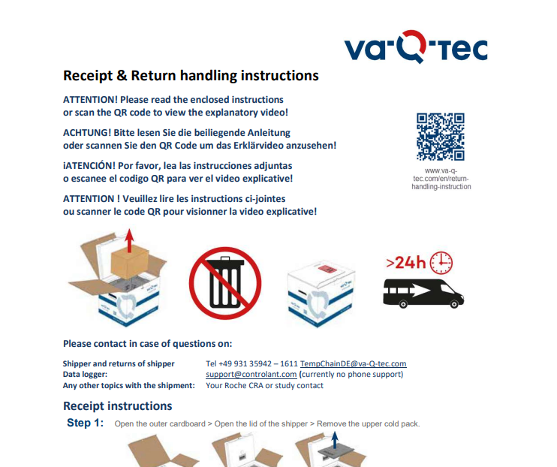
QR code with link to explanatory video

4) Record details of the shipment receipt on the Delivery Note, in the box indicated below.
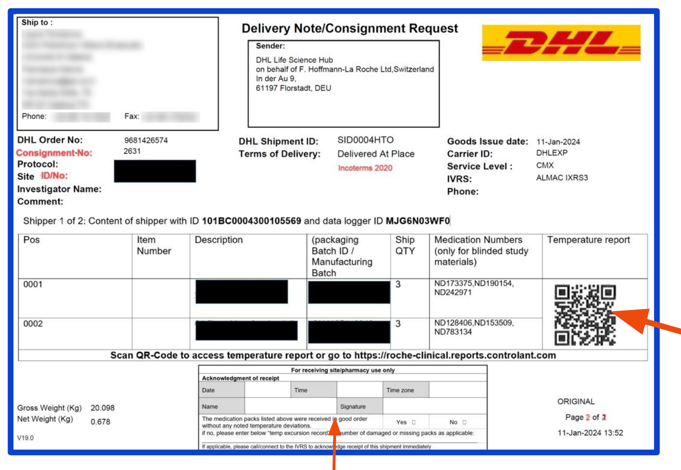
QR code for downloading temperature report
Box for recording details of shipment receipt

5) Scan the QR code on the Delivery Note to download the temperature report. A copy of the temperature report and the Delivery Note should be kept in the Investigator Site File (electronic or physical copies can be kept, according to local preference). The temperature report can also be obtained by emailing the trial team if necessary. Note the instructions may say ‘record the shipment in IxRS (as applicable)’, but this system is not used for RECOVERY shipments.
6) Follow the Receipt and Return handling instructions to prepare the shipper and Smart Sensor for return.

Storage
Store at room temperature (15-30°C). No trial-specific temperature monitoring is required once the material is received by the pharmacy, and this can be done in line with the usual pharmacy practice (the material is equivalent to commercial baloxavir marboxil, which has no temperature storage requirements). If a problem in the storage conditions of the material is identified, then quarantine the material and notify the trial team as above.
All sites will need to ensure clear storage separation between stock for this study and general hospital stock for flu patients or stock used for other clinical trials.

Dispensing
Two doses of baloxavir marboxil, administered by mouth or feeding tube. The first dose is to be given on day 1 and the second dose on day 4. Treatment should be started as soon as possible after the patient is randomised, aiming for a delay of no more than 6 hours. This two-dose regimen is based on evidence from a previous trial in hospitalised patients, and is different to the one-dose regimen licensed for uncomplicated influenza.

If the patient is discharged before the course is complete, they should be provided with the 2nd dose to take at home. The trial follow-up form will record whether or not this happened, but site teams do not need record whether or not the 2nd dose was actually taken by the patient after discharge.

Dosing of baloxavir marboxil depends on the patient’s weight:
<40kg Not eligible for baloxavir marboxil comparison
40kg to <80kg Baloxavir marboxil 40mg on day 1 and day 4
≥80kg Baloxavir marboxil 80mg on day 1 and day 4
No adjustment is needed for patients with renal impairment.

1) Check that the IMP has not passed its expiry date.
2) The following information should be written on the front page of the box and blister label booklets, in the spaces provided:
- ‘Pat no.’ (this can be RECOVERY participant ID or a local hospital number)
- ‘Investigator’ (name of site Principal Investigator, on box only)
- ‘Dispensing date’ or ‘Administration date’ (write the dispensing date for both, as this is also the intended administration date)
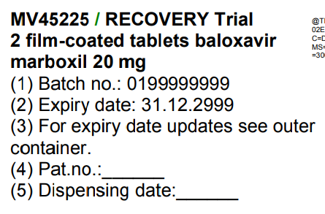
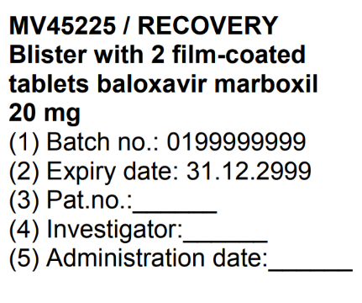

Box Blister

3) Instructions for the second dose should be written on the relevant language page of the box label booklet. The labelling includes spaces to write instructions for the second dose:
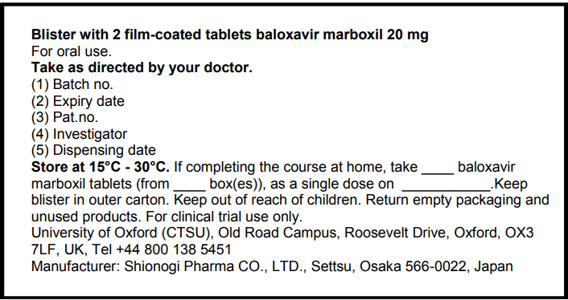

For example, the label would be completed as follows for a patient randomised on 28/11/2025 (day 1):
- If patient weighs <80kg “If completing the course at home, take _2_baloxavir marboxil tablets (from _1_ box(es)), as a single dose on _1/12/2025_”
- If patient weighs ≥80kg “If completing the course at home, take _4_baloxavir marboxil tablets (from _2_ box(es)), as a single dose on _1/12/2025_”

The second dose should be dispensed with the first if possible, so the complete course is held on the ward with the patient. Do not allow dispensing to delay discharge from hospital, as this could introduce bias to trial results for duration of hospital stay.

A record must be kept of baloxavir marboxil deliveries, use, and inventory, in line with usual pharmacy procedures for handling medications. Example accountability logs for baloxavir marboxil with minimally required information are available from the trial website (www.recoverytrial.net/eu/regulatory-documents), but sites may choose to use their own local methods.

Returns and Destruction
Any remaining stock at the end of the trial should be disposed of according to local pharmacy procedures. No sponsor approval is required before destruction, but the sponsor should be informed afterwards that all remaining trial baloxavir marboxil has been destroyed (email recoverytrial@ndph.ox.ac.uk).

Recalls, complaints or use of expired IMP
In the event of a recall, the Oxford trial team will email the PI and pharmacy contact and ask them to quarantine the material immediately, and to provide confirmation of action taken. We will then arrange for the material to be collected.
In case of any IMP-related issues, complaints, or the use of expired IMP, please contact the Oxford trial team (recoverytrial@ndph.ox.ac.uk).

FAQs
Also see the baloxavir marboxil intervention sheet www.recoverytrial.net/eu
Can baloxavir marboxil tablets be cut or crushed for patients who have swallowing difficulties or who have a feeding tube?

The tablets must not be crushed or split. If administering via a feeding tube, the tablets can be dissolved in 100ml water. While the company’s in house data on dispersing tablet has not been tested for enteral administration, baloxavir marboxil suspension is licensed in the US for administration via enteral feeding tube, suggesting drug interaction with tubing is unlikely to be an issue. Given the licensed baloxavir marboxil 2mg/mL suspension is bioequivalent to baloxavir marboxil tablet, and the suspension is a simple suspension formulation (excipients: non-colloidal silicon dioxide, hypromellose, maltitol, mannitol, povidone K25, sodium chloride, strawberry flavour, sucralose and talc), the administration of dispersed tablet suspension is likely to have minimal impact on bioavailability.
For patients who cannot swallow tablets and who do not have a feeding tube, tablets may be dissolved in 100ml water. However, this cannot be mixed with anything to improve taste or alter consistency (e.g. thickener).
How should the tablets be taken?
The tablets must be swallowed whole with or without food. Baloxavir marboxil should not be taken with products that contain polyvalent cations such as laxatives, antacids or oral supplements containing iron, zinc, selenium, calcium or magnesium.
Do tablets contain lactose?
Yes, the tablets contain lactose as an excipient, so patients who are lactose intolerant should not be randomised in the baloxavir marboxil comparison.
My patient is pregnant or breastfeeding, can they be treated with baloxavir marboxil?

No, pregnant or breastfeeding women cannot be randomised to the baloxavir marboxil comparison in the EU.

Version History
Version | Issue Date | Author | Description
1.0 | 2024-02-08 | Leon Peto | First version
2.0 | 2025-10-22 | Vanessa Tobert/Leon Peto | Addition of baloxavir marboxil

Handbook of Drug Administration via Enteral Feeding Tubes ISBN 9780857111623

